RNN

Language Model:

n-grama Language Model:

“Go to school.” The P of (“school”|”go”,”to”) = (count(“go to school”))/(cout(“go to”))

RNN

Timestep

Embedding: transfer learning

Simple RNN; LSTM, Bi-directional, and Deep Bi- directional

Right to left: 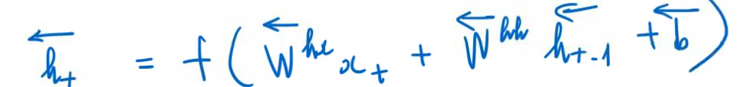 . Improve: LSTM (long short term memories), GRU.

LSTM

